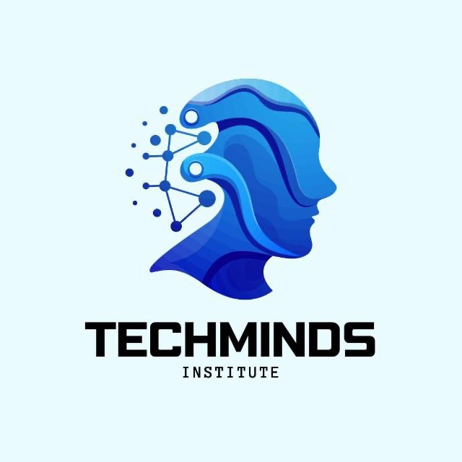

TechMinds Institute is a premier technology solutions provider specializing in web and mobile app development.

Our skilled team combines expertise in software development and user experience to deliver tailored solutions for businesses of all sizes.

We focus on empowering our clients to leverage technology to enhance operations, improve customer engagement, and to drive growth.